mindmanager version 6, how to make a mind map
How To Make a Mind Map®
The 'Laws of Mind Mapping' were originally devised by Tony Buzan when he codified the use of imagery, colour and association and coined the phrase 'Mind Mapping'. In the intervening 30 plus years, there have been many variations on the original 'Mind Map® ' and the widespread usage of mapping software of various sorts, has dramatically changed what is possible.
The summary below is based on Buzan's structure (details available in his many books) but we believe that whilst this structure is great for establishing well structured maps that can be used in many different ways, variations on these rules or 'laws' are often sensible and appropriate - as long as they are based on an understanding of why the laws exist and what they are trying to help the mind mapper to achieve.
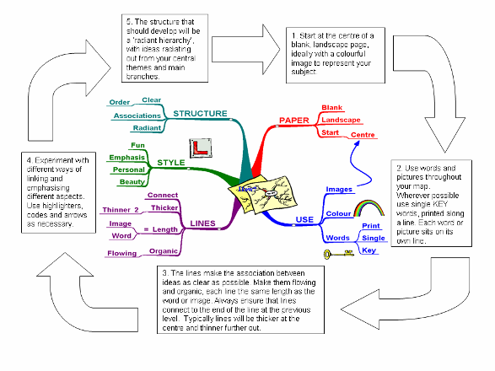
1. Take a blank piece of paper, A4 or larger | Blank paper allows 360º of freedom to express the full range of your cortical skills, whereas pre-drawn lines restrict the natural flow of your thoughts
2. Use the paper in landscape orientation | Words and images have more space in the direction we write, so they don’t bump into margins as quickly
3. Start in the center | Thoughts start in the centre of our mental world. The Mind Map® page reflects this
4. Make a central image that represents the topic about which you are writing /thinking  - use at least three colours  - keep the height and width of the central image to approx. 2’’ or 5 cm (proportionately larger for bigger paper)  - allow the image to create its own shape (do not use a frame) | A picture is worth a thousand words. It opens up associations, focuses the thoughts, is  fun and results in better recall:  - colours stimulate the right cortical activity of imagination as well as capturing and holding attention  - this size gives plenty of space for the rest of your Mind Map®, while making it large enough to be the clear focus of the topic  - the unique shape makes it more memorable and enjoyable. A frame makes the centre a monotony of shape and disconnects the branches
5. The main themes around the central image are like the chapter headings of a book  - print this word in CAPITALS or draw an image  - place on a line of the same length  - the central lines are thick, curved and organic i.e. like your arm joining your body, or the branch of a tree to the trunk  - connect directly to the central image | The main themes, connected to the central image on the main branches, allow their relative importance to be seen. These are the Basic Ordering Ideas (BOIs) and aggregate and focus the rest of the Mind Map®  - printing (versus cursive) allows the brain to photograph the image thus giving easier reading and more immediate recall  - word length equals line length. An extra line disconnects thoughts, length accentuates the connection  - curved lines give visual rhythm and variety and so are easier to remember, more pleasant to draw and less boring to look at. Thicker central lines show relative importance  - Connected to the image because the brain works by association not separated, disconnected lines
7. Start to add a second level of thought. These words or images are linked to the main branch that triggered them. Remember:  - lines connect are thinner  - words are still printed but may be lower case | Your initial words and images stimulate associations. Attach whatever word or image is triggered. Allow the 'random movement of your thought; you do not have to ‘finish’ one branch before moving on  - connected lines create relationships and a structure. They also demonstrate the level of importance, as from a branch to a twig  - the size and style of the letters provide additional data about the importance and meaning of the word/image
Add a third or fourth level of data as thoughts come to you  - Use images as much as you can, instead of, or in addition to the words  - Allow your thoughts to come freely, meaning you ‘jump about’ the Mind Map® as the links and associations occur to you | Your brain is like a multi-handed thought-ball catcher. The Mind Map® allows you to catch and keep whatever ‘thought ball’ is thrown by your brain
9. Add a new dimension to your Mind Map® . Boxes add depth around the word or image | To make some important points stand out
10. Sometimes enclose branches of a Mind Map® with outlines in colour  - enclose the shape of the branch. Hug the shape tightly  - use different colours and styles | The outlines will create unique shapes as you find in clouds and will aid your memory  - these provide immediate visual linking. They can also encourage follow-up and remind you of action you need to take  - they can also show connection between branches by using the same colour outline
11. Make each Mind Map® a little more:  - BEAUTIFUL  - ARTISTIC  - COLOURFUL  - IMAGINATIVE  and  - DIMENSIONAL | Your eyes and brain will be attracted to your Mind Map®  It will be easier to remember  It will be more attractive to you  (and to others as well)
12. Have fun!  Add a little humour, exaggeration or absurdity wherever you can | Your brain will delight in getting the maximum use and enjoyment from this process and will therefore learn faster, recall more effectively and think more clearly
Mind Map® is a registered trademark of the Buzan organisation. Illumine has worked closely with the Buzan organisation throughout its existence. We are an independent training company and are committed to promoting Buzan's work and ideals. We use many highly experienced Buzan licensed instructors as well as our own Illumine licensed Mind Mapping experts.

