South Africa – Background: Timeline - A chronology of key events:
1497 - Portuguese explorer Vasco da Gama lands on Natal coast.
1652 - Jan van Riebeeck, representing the Dutch East India Company, founds the Cape Colony at Table Bay.
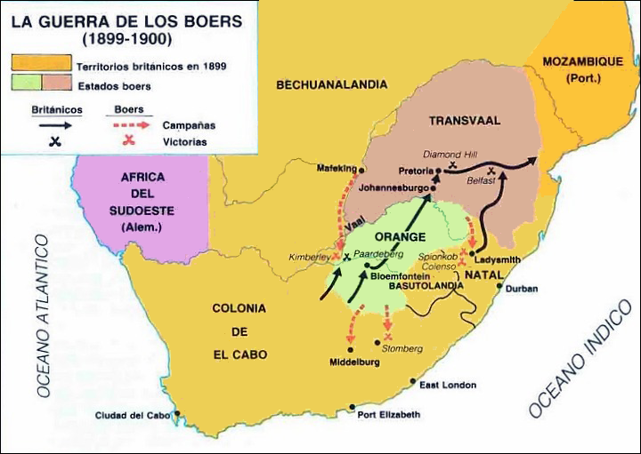
1795 - British forces seize Cape Colony from the Netherlands. Territory is returned to the Dutch in 1803; ceded to the British in 1806.
1816-1826 - Shaka Zulu founds and expands the Zulu empire, creates a formidable fighting force.
1835-1840 – Boers (the Dutch) leave Cape Colony in the 'Great Trek' and found the Orange Free State and the Transvaal.
Late 1850s - Boers proclaim the Transvaal a republic.
1877 - Britain annexes the Transvaal.
1879 - British defeat the Zulus in Natal.
1880-81 - Boers rebel against the British, sparking the first Anglo-Boer War. Conflict ends with a negotiated peace. Transvaal is restored as a republic.
Mid 1880s - Gold is discovered in the Transvaal, triggering the gold rush.
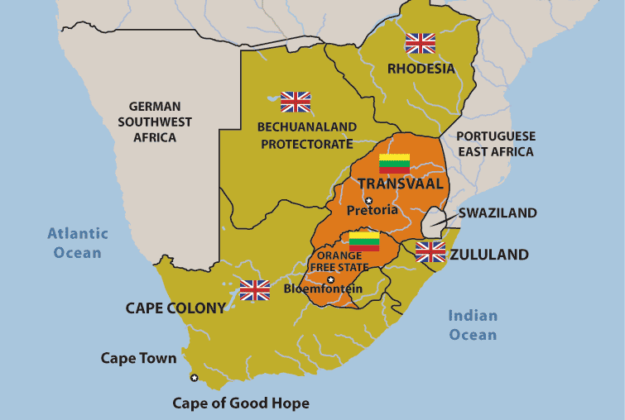
1899 - British troops gather on the Transvaal border and ignore an ultimatum to disperse. The second Anglo-Boer War begins.
1910 - Formation of Union of South Africa by former British colonies of the Cape and Natal, and the Boer republics of Transvaal, and Orange Free State.
1912 - Native National Congress founded, later renamed the African National Congress (ANC).
1913 - Land Act introduced to prevent blacks, except those living in Cape Province, from buying land outside reserves.
1914 - National Party founded.
1918 - Secret Broederbond (brotherhood) established to advance the Afrikaner cause.
1919 - South West Africa (Namibia) comes under South African administration.
1934 - The Union of South Africa parliament enacts the Status of the Union Act, which declares the country to be "a sovereign independent state". The move followed on from Britain's passing of the Statute of Westminster in 1931, which removed the last vestiges of British legal authority over South Africa.
Apartheid set in law
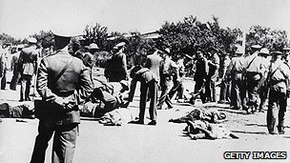
1948 - Policy of apartheid (separateness) adopted when National Party (NP) takes power.
1950 - Population classified by race. Group Areas Act passed to segregate blacks and whites. Communist Party banned. ANC responds with campaign of civil disobedience, led by Nelson Mandela.
1960 - Seventy black demonstrators killed at Sharpeville. ANC banned.
1961 - South Africa declared a republic, leaves the Commonwealth. Mandela heads ANC's new military wing, which launches sabotage campaign.
1960s - International pressure against government begins, South Africa excluded from Olympic Games.
1964 - ANC leader Nelson Mandela sentenced to life imprisonment.
1970s - More than 3 million people forcibly resettled in black 'homelands'.
1976 - More than 600 killed in clashes between black protesters and security forces during uprising which starts in Soweto.
1984-89 - Township revolt, state of emergency.
1989 - FW de Klerk replaces PW Botha as president, meets Mandela. Public facilities desegregated. Many ANC activists freed.
1990 - ANC unbanned, Mandela released after 27 years in prison. Namibia becomes independent.
1991 - Start of multi-party talks. De Klerk repeals remaining apartheid laws, international sanctions lifted. Major fighting between ANC and Zulu Inkatha movement.
1993 - Agreement on interim constitution.
1994 April - ANC wins first non-racial elections. Mandela becomes president, Government of National Unity formed, Commonwealth membership restored, remaining sanctions lifted. South Africa takes seat in UN General Assembly after 20-year absence.
Seeking truth
1996 - Truth and Reconciliation Commission chaired by Archbishop Desmond Tutu begins hearings on human rights crimes committed by former government and liberation movements during apartheid era.
1996 - Parliament adopts new constitution. National Party withdraws from coalition, saying it is being ignored.
1998 - Truth and Reconciliation Commission report brands apartheid a crime against humanity and finds the ANC accountable for human rights abuses.
1999 - ANC wins general elections, Thabo Mbeki takes over as president.
2000 December - ANC prevails in local elections. Recently-formed Democratic Alliance captures nearly a quarter of the votes. The Inkatha Freedom Party wins 9%.
2002 April - Court acquits Dr Wouter Basson - dubbed "Dr Death" - who ran apartheid-era germ warfare programme. Basson had faced charges of murder and conspiracy. ANC condemns verdict.
2002 October - Bomb explosions in Soweto and a blast near Pretoria are thought to be the work of right-wing extremists. Separately, police charge 17 right-wingers with plotting against the state.
2005 August - Around 100,000 gold miners strike over pay, bringing the industry to a standstill.
2006 May - Former deputy president Jacob Zuma is acquitted of rape charges by the High Court in Johannesburg. He is reinstated as deputy leader of the governing African National Congress.
Mass strike
2007 June - Hundreds of thousands of public-sector workers take part in the biggest strike since the end of apartheid. The strike lasts for four weeks and causes widespread disruption to schools, hospitals and public transport.
2007 December - Zuma is elected chairman of the ANC, placing him in a strong position to become the next president. Prosecutors bring new corruption charges against him.
2008 May - Wave of violence directed at foreigners hits townships across the country. Dozens of people die and thousands of Zimbabweans, Malawians and Mozambicans return home.
2009 May - Parliament elects Jacob Zuma as president.
2009 July - Township residents complaining about poor living conditions mount violent protests.
2010 June - South Africa hosts the World Cup football tournament. (movie Invictus based on this)
2010 August - Civil servants stage nation-wide strike.
2012 July - Member of white extremist group found guilty of plotting to kill Mandela and trying to overthrow government.
2012 August-October - Police open fire on workers at a platinum mine in Marikana, killing at least 34 people, and leaving at least 78 injured and arresting more than 200 others. Prosecutors drop murder charges in September against 270 miners after a public outcry, and the government sets up a judicial commission of inquiry in October.
2012 December - President Zuma re-elected as leader of the ANC.
2013 June - Former president Nelson Mandela, aged 94, admitted to hospital for the fourth time in the past year.
2013 December - Nelson Mandela dies, aged 95. Tributes to "the father of the nation" flood in from throughout the world

The History of Apartheid in South Africa
South Africa (see map) is a country blessed with an abundance of natural resources including fertile farmlands and unique mineral resources. South African mines are world leaders in the production of diamonds and gold as well as strategic metals such as platinum. The climate is mild, reportedly resembling the San Francisco bay area weather more than anywhere in the world.
South Africa was colonized by the English and Dutch in the seventeenth century. English domination of the Dutch descendents (known as Boers or Afrikaners) resulted in the Dutch establishing the new colonies of Orange Free State and Transvaal. The discovery of diamonds in these lands around 1900 resulted in an English invasion which sparked the Boer War. Following independence from England, an uneasy power-sharing between the two groups held sway until the 1940's, when the Afrikaner National Party was able to gain a strong majority. Strategists in the National Party invented apartheid as a means to cement their control over the economic and social system. Initially, aim of the apartheid was to maintain white domination while extending racial separation. Starting in the 60's, a plan of ``Grand Apartheid'' was executed, emphasizing territorial separation and police repression.
With the enactment of apartheid laws in 1948, racial discrimination was institutionalized. Race laws touched every aspect of social life, including a prohibition of marriage between non-whites and whites, and the sanctioning of ``white-only'' jobs. In 1950, the Population Registration Act required that all South Africans be racially classified into one of three categories: white, black (African), or colored (of mixed decent). The coloured category included major subgroups of Indians and Asians. Classification into these categories was based on appearance, social acceptance, and descent. For example, a white person was defined as ``in appearance obviously a white person or generally accepted as a white person.'' A person could not be considered white if one of his or her parents were non-white. The determination that a person was ``obviously white'' would take into account ``his habits, education, and speech and deportment and demeanor.'' A black person would be of or accepted as a member of an African tribe or race, and a colored person is one that is not black or white. The Department of Home Affairs (a government bureau) was responsible for the classification of the citizenry. Non-compliance with the race laws were dealt with harshly. All blacks were required to carry ``pass books'' containing fingerprints, photo and information on access to non-black areas.
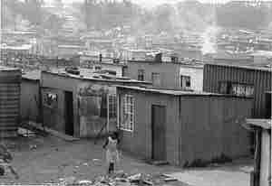
In 1951, the Bantu Authorities Act established a basis for ethnic government in African reserves, known as ``homelands.'' These homelands were independent states to which each African was assigned by the government according to the record of origin (which was frequently inaccurate). All political rights, including voting, held by an African were restricted to the designated homeland. The idea was that they would be citizens of the homeland, losing their citizenship in South Africa and any right of involvement with the South African Parliament which held complete hegemony over the homelands. From 1976 to 1981, four of these homelands were created, denationalizing nine million South Africans. The homeland administrations refused the nominal independence, maintaining pressure for political rights within the country as a whole. Nevertheless, Africans living in the homelands needed passports to enter South Africa: aliens in their own country.
In 1953, the Public Safety Act and the Criminal Law Amendment Act were passed, which empowered the government to declare stringent states of emergency and increased penalties for protesting against or supporting the repeal of a law. The penalties included fines, imprisonment and whippings. In 1960, a large group of blacks in Sharpeville refused to carry their passes; the government declared a state of emergency. The emergency lasted for 156 days, leaving 69 people dead and 187 people wounded. Wielding the Public Safety Act and the Criminal Law Amendment Act, the white regime had no intention of changing the unjust laws of apartheid.
The penalties imposed on political protest, even non-violent protest, were severe. During the states of emergency which continued intermittently until 1989, anyone could be detained without a hearing by a low-level police official for up to six months. Thousands of individuals died in custody, frequently after gruesome acts of torture. Those who were tried were sentenced to death, banished, or imprisoned for life, like Nelson Mandela.
The apartheid policy was highly effective of achieving its goal of preferential treatment for whites, as is demonstrated by the statistics in Figure 1.

